 2025/26
Net Zero Strategy
Net zero strategy
Helen McInnes

Table of Contents
Background 2
SCARF 2
HEAT 2
HES 2
Introduction 3
Our Net Zero Strategy 4
Assessing our current carbon footprint 4
Setting clear, achievable goals 6
Developing a carbon emissions reduction plan 7
Engaging our team 8
Monitoring, reporting, and adjusting 10
Benefits of implementing a Net Zero strategy 11
Net Zero Terms and Definitions 12

Background

SCARF
SCARF is a charity and social enterprise based in Aberdeen and Dundee, and was founded in 1985 as a social improvement programme in Aberdeen. SCARF has gone on to support over 100,000 homes across Scotland to reduce their energy bills, improve their homes' energy efficiency, and reduce fuel debt. SCARF continues to expand across the North East, Fife, Falkirk, Argyll and Bute, and North Lanarkshire. SCARF is working towards a greener and fairer Scotland in which people can live a comfortable, warm life.

HEAT
SCARF has been delivering the Home Energy Advice Team since it was founded in 1985 and is funded by a mixture of Local Authorities, Energy Companies and Private Business. The programme offers in-home free advice and support to help you make your home warmer, reduce your energy bills looking at advice and practical measures. The in-home advice team provides additional wraparound support such as income maximisation, referrals to other organisations to support the household with the appropriate organisations and give them the tools to try and get out of fuel poverty.
HEAT’s primary focus is on tackling fuel poverty and providing in-home advice to educate the households and where possible improve the EPC of the property to have a warmer more efficient home.

HES
Home Energy Scotland was founded in 2008 and offers free advice and support to help you make your home warmer, reduce your energy bills, and contribute to a greener, more sustainable future. Our service is funded by the Scottish Government and managed by Energy Saving Trust. HES is committed to positively impacting the lives of people throughout Scotland.
HES' primary focus is on tackling fuel poverty and the climate emergency. This is delivered by giving people clear and impartial advice on making their home cheaper to heat, as well as reducing their carbon footprint - both critical priorities for the Scottish Government.

Introduction
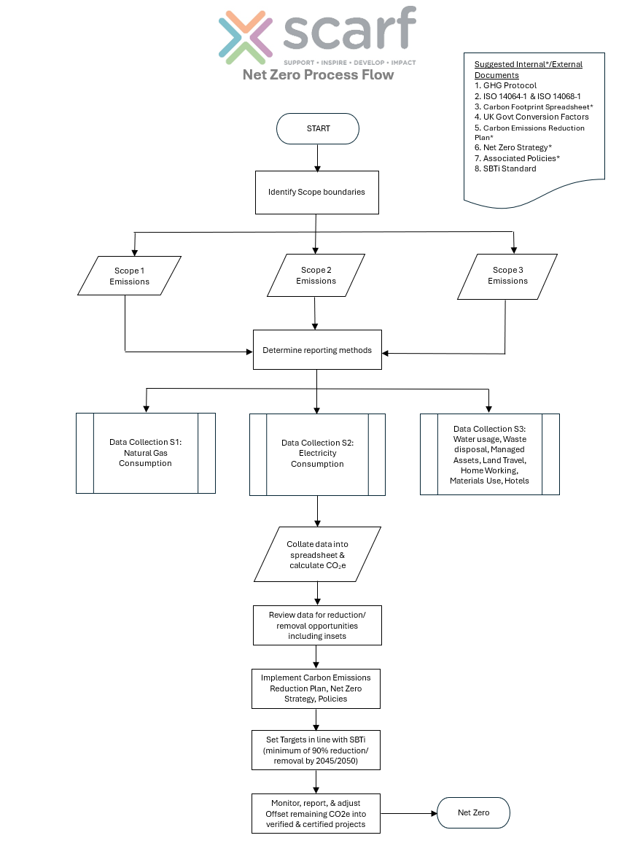
SCARF is a socially responsible company that aims to reduce our carbon emissions in line with Science-Based Target initiatives (SBTi). Reductions will be achieved through a range of near-term and long-term actions. Near-term targets outline what we will do now and over the next 5-10 years to reduce emissions.

This Net Zero Plan, viewed as a “live” document, sets out our strategy for action and a roadmap for progress to achieve net zero by 2045 as determined by the Scottish Government.

How do we intend to do this? By –
- Assessing our current carbon footprint
- Setting clear, achievable goals
- Developing a carbon emissions reduction plan
- Engaging our SCARF and HES Teams
- Monitoring, reporting, and adjusting

Reducing greenhouse gas (GHG) emissions is not just about our commitment to decreasing the effects of climate change. It is also about identifying and achieving financial savings through improved efficiency to help grow our business sustainably. We aim to detail savings from all our actions, wherever possible.

The lead for this project is David Mackay, SCARF’s Co-CEO. We commit to regularly monitoring our progress and reporting annually, openly and transparently.

Our Net Zero Strategy

Assessing our current carbon footprint
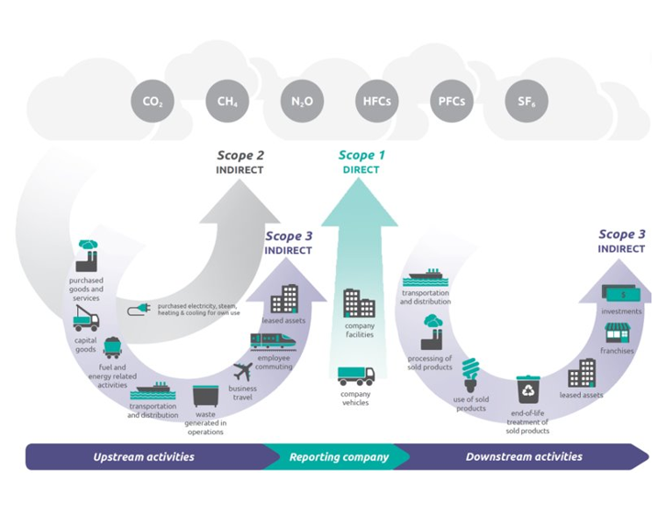
We will record and calculate the total greenhouse gas (GHG) emissions produced directly and indirectly by our business activities using the GHG Protocol, ISO 14064-01, and the UK Government Conversion Factors for Company Reporting.

We have set out Scope and Boundaries of the carbon footprint: - Organisational Boundary (sets out which assets are to be included in the footprint) and Operational Boundary (emission sources to be included in our footprint, shown in Table 1 below).

In keeping with the Greenhouse Gas (GHG) Protocol, our Operational Boundary will include applicable Scope 1 and 2 emissions. Scope 3 emissions are considered optional, but we have included these where data is available, as scope 3 will account for the largest proportion of emissions for most companies, including ourselves.

Table 1 CO2e Scopes (emission sources)
Scope 1 | Scope 2 | Scope 3
Natural Gas Consumption | UK Electricity Consumption | Water Supply | Waste Disposal | Managed Assets - Vehicles
 |  | Water Treatment | WTT Passenger Vehicle & Travel – Land* | Home Working
 |  | Material Use | Hotel Stay

Based on this, we have set a near-term target to reduce our total annual GHG emissions which will be delivered by achieving our annual targets which will be released in our annual Carbon Emissions Reduction Plan (SCA-IMS-076) by the end of the financial year 2030, which equates to a 50% reduction. This will keep us on track to achieve our long-term target of reaching net zero by 2045.

The data sources used in our baseline emissions are based on robust data provided by both internal and external as demonstrated in the table below. Data is collated and converted to a CO₂e tonnage equivalent using DESNZ factors for Company Reporting. The chosen reporting year was 2025/26.

Table 2 Data Sources
Data | Source | Units
Natural Gas (S1) | Half-hourly data is provided by the supplier on a monthly basis. | kWh
Electricity (S2) | Half-hourly data is provided by the supplier on a monthly basis. | kWh
Water (S3) | Summary of usage provided by the supplier. | m³
Material Use (S3) | Calculated by £ spent. | £
Waste (S3) | Monthly breakdown of waste (Dry Mixed Recycling, Waste to Energy, and Waste to Landfill) provided by the waste contractor. | Kg
Employee Commuting* (S3) | An employee survey is conducted on a weekly basis. | miles
Business Travel* (S3) | Employees are asked to calculate mileage on a weekly basis | miles
Hotel Stays (S3) | No. of nights provided by supplier on a monthly basis. | # of nights
Managed Assets - Vehicles (S3) | Monthly fuel use is used to estimate each vehicle's mileage. | miles
Home Working (S3) | An employee survey is conducted on a weekly basis. | # of days

Setting clear, achievable goals

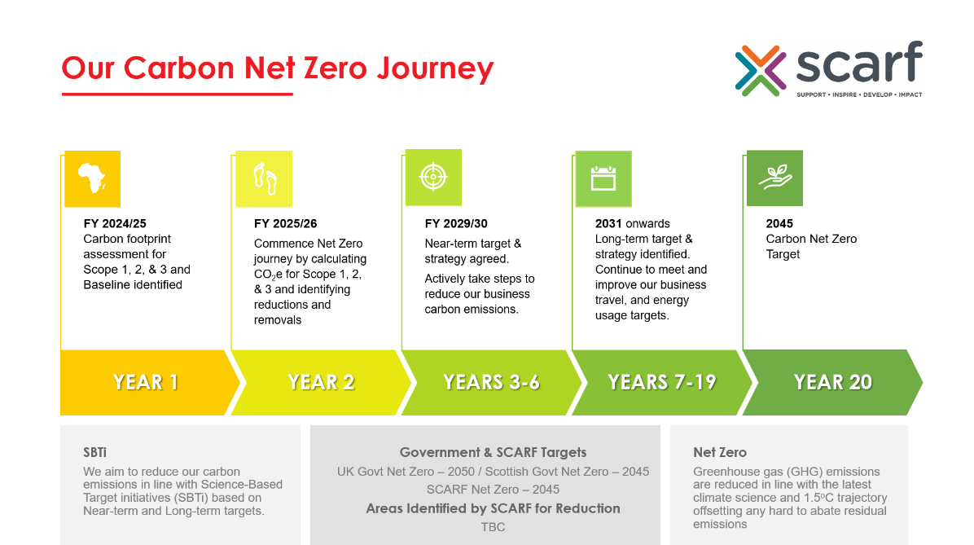
The Earth is about 1.2°C warmer than the late 1800s, and emissions continue to rise. Emissions need to be reduced by 45% by 2030 and reach net zero by 2050, or 2045 as determined by the Scottish Government, to keep global warming to no more than 1.5°C, as called for in the Paris Agreement (United Nations).

We will set our emission reduction goals based on the SMART principle – Specific, Measurable, Achievable, Relevant, and Timely. These, in turn, will align with the Science-Based Target initiative (SBTi) standard and with the Scottish Government's commitment to reach Net Zero gas emissions by 2045. This alignment demonstrates our commitment to fighting climate change while supporting the transition to a sustainable economy.

These targets will be reported annually with openness and transparency.

Developing a carbon emissions reduction plan

We have developed a Carbon Emissions Reduction Plan (SCA-IMS-076) to help us identify strategies to reduce emissions. Strategies may involve improving energy efficiency of our operations and facilities in our Aberdeen and Dundee locations; transitioning to renewable energy sources such as ground heat pumps and continuing with solar power; and investing in green technologies.

We are committed to identifying and implementing emissions reduction projects to achieve our Net Zero target. Actions based on our emissions baseline are set out in our Carbon Emissions Reduction Plan.

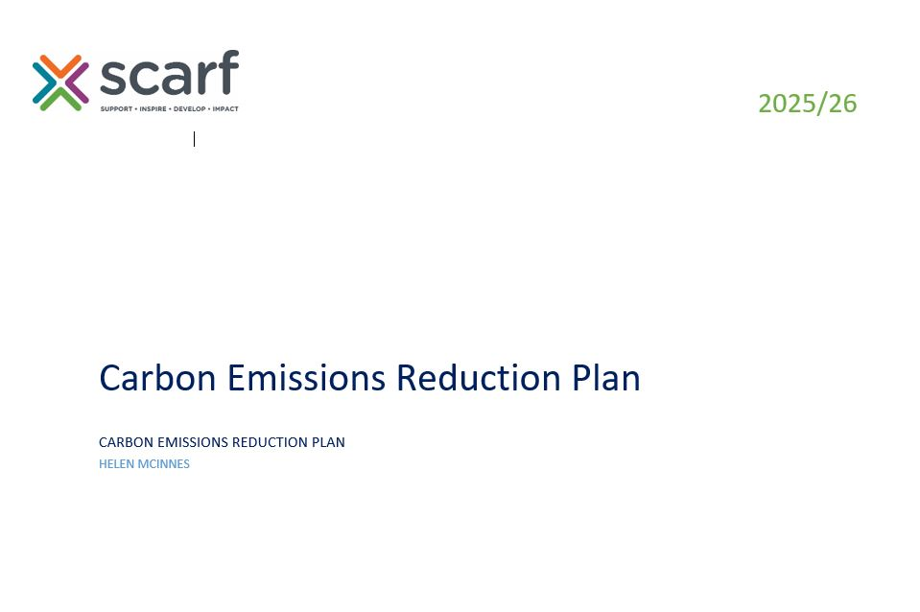
Short-Term Projects (immediate – 5 years)
- Greater use of the company-owned full Electric Vehicle (EV)
- Installing a water harvesting system (water butts) to use for tasks such as vehicle washing
- Replacing our current kettles with the energy-efficient ‘hot taps’ or kettles
- Move to renewable energy/green tariffs
- Track and collect data from suppliers
- Providing driver awareness training to all drivers
- Undertake a full waste audit every quarter and provide feedback results to staff
Near-Term Projects (5-10 years)
- Halving our emissions by 2030
- Installing low-volume or two-flush toilets in our buildings
- Decarbonising our leased fleet of vehicles from hybrid to full EV
- Replace the fossil fuel (gas) boiler with ground heat pump/s (GHP)
- Reinsulating our current premises (consider biobased insulation materials such as wood fibre, hemp, etc.)
Long-Term Projects (10-20 years)
- Moving to zero-carbon-ready location/s
- Encourage at least 50% of our vehicle owning employees to personnel to buy an electric vehicle by implementing a “salary sacrifice” scheme

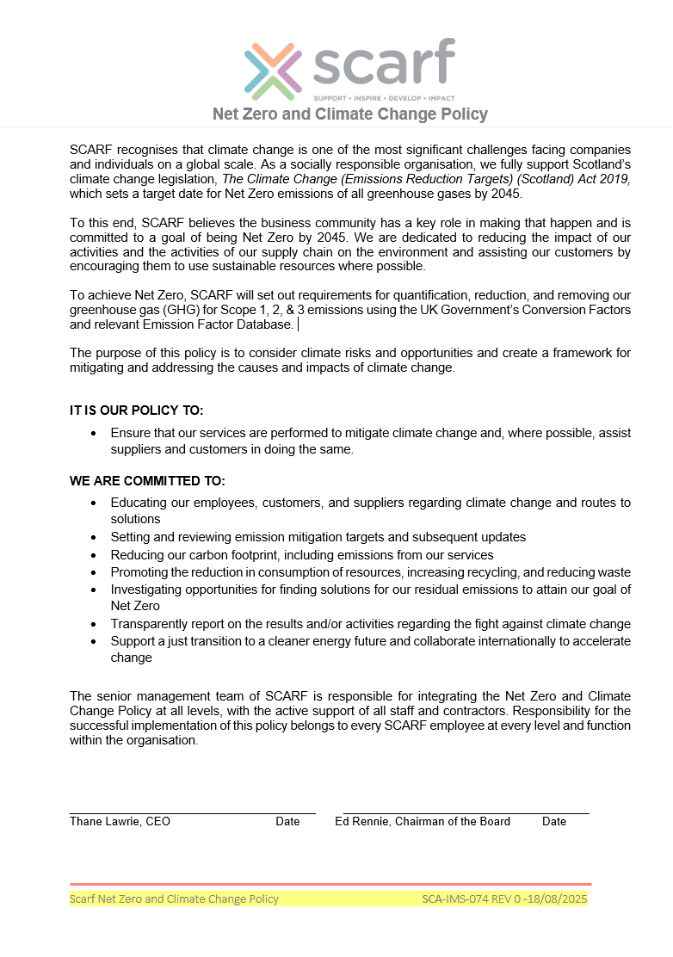
Engaging our team

The key to the success of our Net Zero Strategy is effective engagement with staff and our stakeholders. We will discuss, communicate, and update our SCARF and HES Teams in relation to this Net Zero Strategy and the supporting Carbon Emission Reduction Plan. We will seek their opinions and ideas on ways of reducing our carbon emissions and involve them in the implementation of appropriate Science-Based Target initiatives (SBTi).

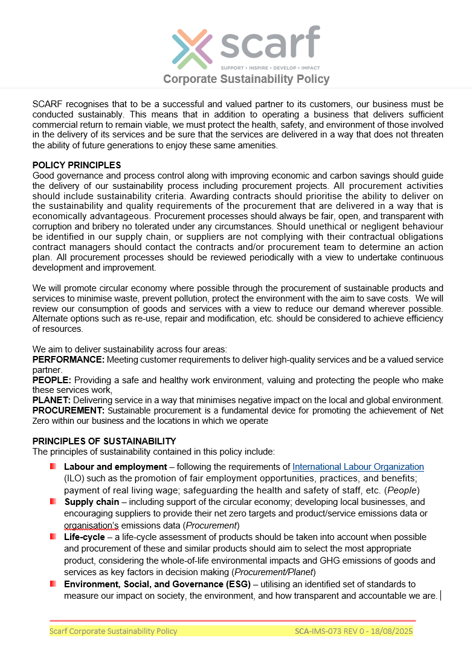
Everyone has a role to play in embedding and delivering the Net Zero Strategy, and collaborative working is essential to deliver the desired carbon savings. We will encourage our Teams to adopt any identified improvements and initiatives not only in the workplace but also at home, where possible. We will celebrate each achievement, large or small.

We have implemented a Net Zero and Climate Change Policy (SCA-IMS-074) and a Corporate Sustainability Policy (SCA-IMS-073) to guide us on our journey.

“SCARF recognises that to be a successful and valued partner to its customers, our business must be conducted sustainably. This means that in addition to operating a business that delivers sufficient commercial return to remain viable, we must protect the health, safety, and environment of those involved in the delivery of its services and be sure that the services are delivered in a way that does not threaten the ability of future generations to enjoy these same amenities.” - SCA-IMS-073

“SCARF recognises that climate change is one of the most significant challenges facing companies and individuals on a global scale. As a socially responsible organisation, we fully support Scotland’s climate change legislation, The Climate Change (Emissions Reduction Targets) (Scotland) Act 2019, which sets a target date for Net Zero emissions of all greenhouse gases by 2045.” - SCA-IMS-074

We will establish a Net Zero Committee, which will have responsibility for the strategic direction and implementation of the Net Zero Strategy. The Committee, as noted in Table 3 below, will meet quarterly basis to
- monitor SCARF’s performance against our CO2e targets
- raise the profile of our Net Zero Strategy in the community and promote environmentally sustainable behaviour by staff, visitors, contractors, and suppliers
- review and policies for consideration by the Senior Management Team
- ensure effective communication of the organisation's policies and plans to the SCARF and HES Teams

Table 3 SCARF’s Net Zero Committee
Name | Current Role | Committee Role | Responsibilities
David Mackay | Co-CEO | Net Zero Project Lead | Ultimately, responsibility for coordinating the implementation of the Net Zero Strategy and reporting on progress.
Zaysha Hope | Administrator | CO₂e Data Coordinator | Coordinating the data collection process required to measure progress
Christine Sellers | Business Support Coordinator | Green Champion | Raise awareness and engage staff to promote environmentally aware behaviour
Scott O’Neill | Scarf Marketing Manager | Communications | Deliver Net Zero awareness training and provide updates to staff, and information to external interested parties

The Net Zero Committee has developed a planned approach to raising awareness of our Net Zero targets through the development of an internal and external communications and awareness strategy. Internally – training and awareness of the Net Zero Strategy, Carbon Emissions Reduction Plan, and any associated documentation, such as policies and templates. Externally – updates on SCARF’s Net Zero Strategy and Projects to interested parties such as customers, stakeholders, suppliers, etc.

Monitoring, reporting, and adjusting

The Net Zero Strategy and Carbon Emissions Reductions Plan are viewed as ‘live’ documents. We commit to reviewing our progress regularly and publishing annual updates, and carbon and financial savings from all our actions, on our website, company reports, and social media platforms as applicable. We will adjust our strategy to meet our targets, and we aim to learn from successes and challenges. This aligns with the requirements of our Integrated Management System (IMS), certified to ISO 9001:2015 and ISO 14001:2015 by a UKAS-accredited certification body.

We recognise that implementing a Net Zero Strategy isn’t just a considered business decision but a moral obligation.

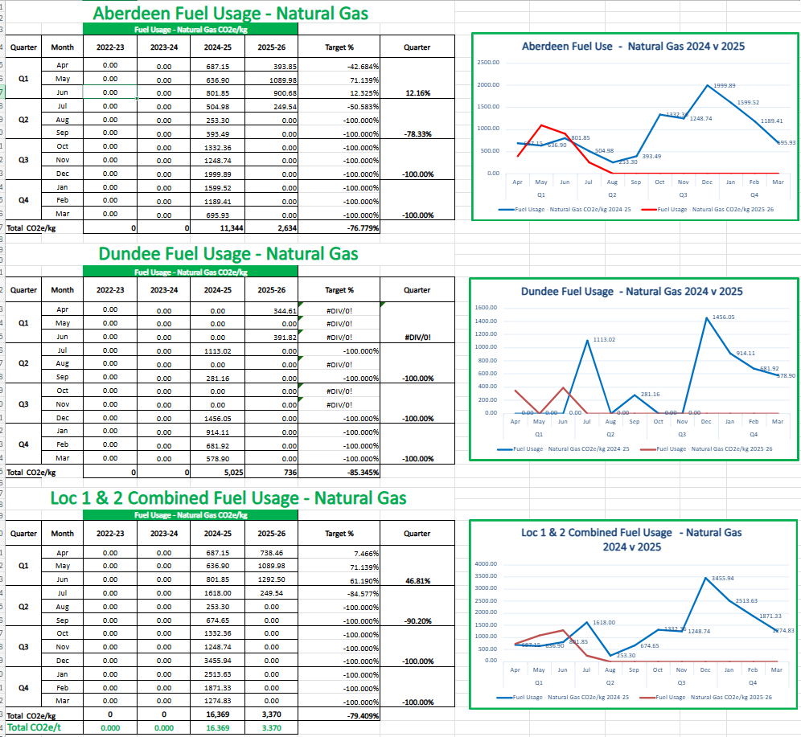
The following areas of the Carbon Emissions Reductions Plan will be subject to annual review:
- Progress towards the overall Net Zero target, including CO₂e savings and benefits
- Progress with identified emission reduction actions
- Financial savings achieved as a result of completed actions
- Wider benefits for the SCARF and beyond

Our Carbon Emissions are recorded in our Carbon Footprint Register (SCA-IMS-050), which is regularly updated and reviewed. Data measuring the progress of the Carbon Emissions Reductions Plan will be collected monthly by the CO₂e Data Coordinator and presented to the Net Zero Committee on a quarterly basis.

Data collected will include:
- Progress on specific projects
- Details of the performance contributing to the emissions, such as utilities, water, fuel, waste
generated, etc.

Benefits of implementing a Net Zero strategy

Implementing a Net Zero strategy offers many benefits, not only to SCARF as a company but also for combating the global climate crisis.

- Climate change – we aim to lower our environmental impact and decrease our carbon footprint, thereby helping to reduce climate change.
- Economic advantages – through energy-efficient practices, we can make cost savings within our business
- Legislative compliance – by adopting a Net Zero strategy, it will aid us with legislative compliance
- Enhance our reputation – achieving the above will enhance our brand image and appeal to eco-conscious customers and investors
- Efficiency and costs – following our Net Zero strategy will help us increase business efficiency and lower costs
- Emission management – measuring our CO2e allows us to effectively manage our emissions and demonstrate reduction of emissions over time
- Demonstrate reduction – we can inform internal and external stakeholders of our Net Zero journey by calculating our emissions
- Risks and opportunities – our Net Zero strategy will mitigate risks and identify opportunities
- Efficiency – we aim to be more efficient in our use of resources and achieve value for money
- Sustainable development – our commitment to achieving sustainable development objectives, including the development of local skills, jobs, and businesses, is demonstrated through our Net Zero strategy
- Circular economy – we support the circular economy
- Improving conditions – wherever possible, we will improve the working conditions of staff across our supply chains
- Due diligence – we will perform supply chain due diligence not only for our own benefits but for that of our stakeholders and investors

Net Zero Terms and Definitions

B
Baseline – quantified greenhouse gas (GHG) emissions and or GHG removals of a subject for a base period (ISO 14068-1:2023)
Base Period – specific, historical period identified for the purpose of comparing greenhouse gas (GHG) emission or GHG removals or other GHG-related information over time (ISO 14068-1:2023)
Boundary – (organization) grouping of greenhouse gas (GHG) emissions or GHG removals reported from within the organization boundary, as well as through significant indirect GHG emissions that are a consequence of the organization’s operations and activities (ISO 14068-1:2023)
Boundary – (system) set of criteria representing which unit processes are part of the product (goods or service) system under study (ISO 14068-1:2023)
C
Carbon Credit – tradeable certificate representing one tonne of CO₂e from GHG emission reductions or GHG removal enhancements (ISO 14068-1:2023)
CO₂ – Carbon Dioxide, a greenhouse gas and the biggest contributor to global carbon emissions caused by burning fossil fuels, specifically coal, oil, and gas to make electricity, used in transportation and industry, deforestation, and primarily linked to human activities
CO₂e – Carbon Dioxide Equivalent, a standard unit for measuring the warming effect of different greenhouse gases
Carbon Insetting – interventions along a company’s value chain that are designed to generate GHG emissions reductions and carbon storage, and, at the same time, create positive impacts for communities, landscapes, and ecosystems (International Platform for Insetting)
Carbon Offsetting – counterbalancing of the carbon footprint by retiring a carbon credit (ISO 14068-1:2023)
Carbon Neutral – the condition in which, during a specified period of time, the carbon footprint has been reduced as a result of greenhouse gas (GHG) emission reductions or GHG removal enhancements and, if greater than zero, is then counterbalanced by offsetting (ISO 14068-1:2023)
Circular Economy – The circular economy is a sustainable system designed to eliminate waste and keep resources in use, creating economic, environmental, and social benefits (Zero Waste Scotland)
Climate Change Mitigation – human intervention to reduce greenhouse gas (GHG) emissions or enhance GHG removals (ISO 14068-1:2023)
D
Direct Greenhouse Gas Emission – owned or controlled by the reporting organisation
G
Global Warming Potential (GWP) – a measure of how much energy the emission of 1 ton of a gas will absorb over a given period of time, relative to the emission of 1 ton of carbon dioxide (GHG Protocol GWP Values)
Greenhouse Gas (GHG) – gases in the earth's atmosphere that trap heat; seven (7) direct greenhouse gases identified under the Paris Agreement: Carbon Dioxide (CO₂), Methane (CH₄), Nitrous oxide (N₂O), Hydrofluorocarbons (HFCs), Perfluorocarbons (PFCs), Sulphur hexafluoride (SF₆), Nitrogen trifluoride (NF₃)
Greenhouse Gas Emission – release of GHG into the atmosphere (ISO 14068-1:2023)
Greenhouse Gas Removal – withdrawal of GHG from the atmosphere by GHG Sink (ISO 14068-1:2023)
GHG Sink – a process that removes GHG from the atmosphere (ISO 14068-1:2023)
I
Interested Party – person or organization that can affect, or be affected by, or perceive itself to be affected by a decision or activity (ISO 14068:2023)
ISO – International Organization for Standardization: worldwide federation of national standards bodies (ISO member bodies) (ISO 14068-1:2023)
ISO 14064-1:2018 – Greenhouse Gases Part 1: Specification with guidance at the organization level for quantification and reporting of greenhouse gas emissions and removals (ISO 14064-1:2018)
ISO 14068-1:2023 – Climate change management — Transition to net zero Part 1: Carbon neutrality (ISO 14068:2023)
Indirect Greenhouse Gas Emission – not owned or controlled by the reporting organisation
N
Net Zero – Net zero means cutting carbon emissions to a small amount of residual emissions that can be absorbed and durably stored by nature and other carbon dioxide removal measures, leaving zero in the atmosphere (United Nations)
R
Reporting Period – specific historical period selected for the determination of carbon neutrality (ISO 14064-1:2018)
S
Science-Based Target Initiative (SBTi) – is a corporate climate action organization that enables companies and financial institutions worldwide to play their part in combating the climate crisis (Science-Based Target Initiative)
Stakeholder – person or organization that can affect, or be affected by, or perceive itself to be affected by a decision or activity (ISO 14068-1:2023)
U
United Nations (UN) – The United Nations is an international organization founded in 1945. Currently made up of 193 Member States, the UN and its work are guided by the purposes and principles contained in its founding Charter (United Nations)
United Nations Development Programme (UNDP) – works in about 170 countries and territories, helping to eradicate poverty, reduce inequalities and exclusion, and build resilience so countries can sustain progress (United Nations Development Programme)
United Nations Sustainable Development Goals (UN SDG) – also known as the Global Goals, were adopted by the United Nations in 2015 as a universal call to action to end poverty, protect the planet, and ensure that by 2030 all people enjoy peace and prosperity. (United Nations Sustainable Development Goals)
V
Value Chain – entire sequence of activities or parties that provide (suppliers, outsourced workers, contractors) or receive (customer, consumers, clients, or other users) value. For a product, the value chain includes its full life cycle, including end of life. For an organization, the value chain includes upstream and downstream activities (ISO 14068-1:2023)

